# DIS-Asia-Indus-Elephant- 2200-1800 BCE

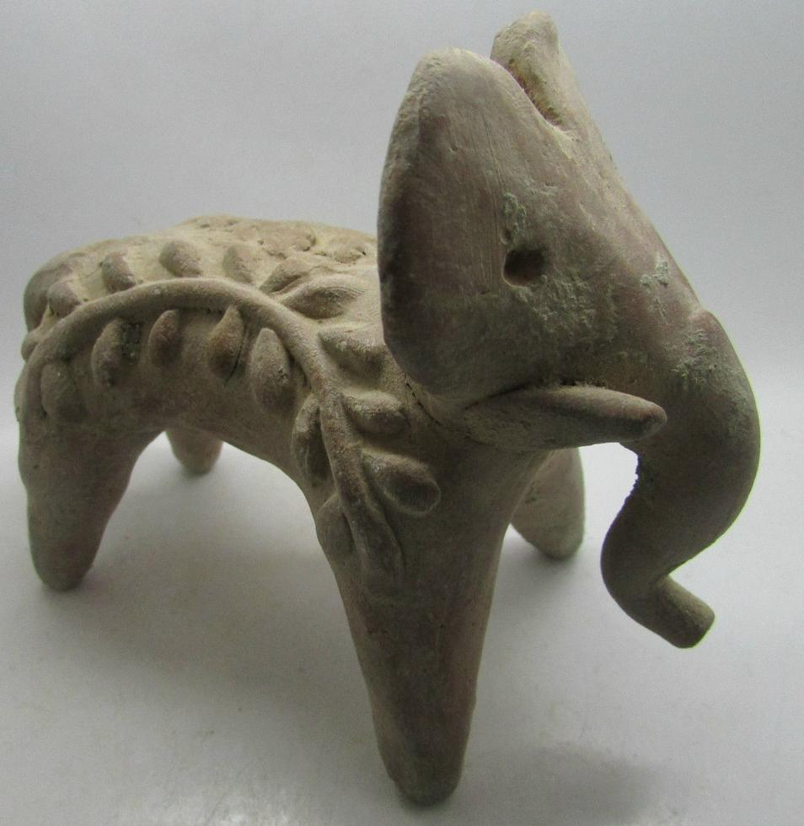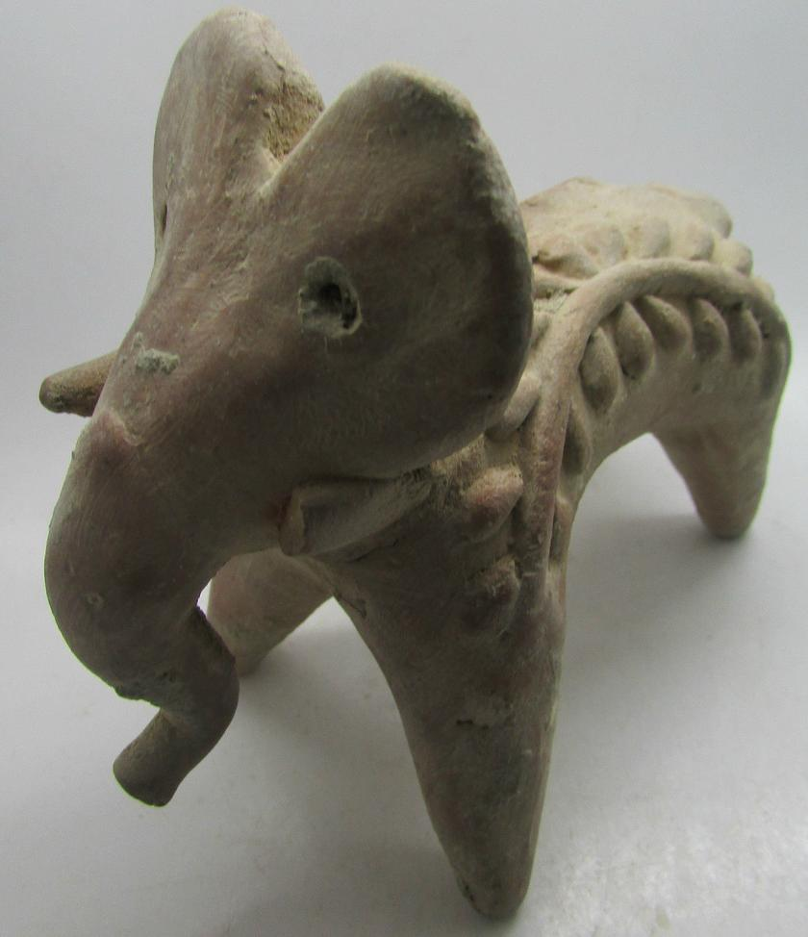

# Indus valley terracotta elephant figurine C. 2200-1800BC

EX Michael Davies, 2 Hanover Court, Didcot, Oxfordshire, ox11 8nu, United Kingdom